1) Introduction (Your Role And Responsibilities):
Our game is “Stacked” it is a stealth co-operative game, where the players are two kids, one cat and one dog, that must work together to acquire items that aren't meant for kids. I am the level designer for our game, as well as helping with assets and a little bit of coding. For this iteration, we have done one level to focus on and get the core mechanics done. It has gone through about three iterations to get to the current level. For the level, I created the level as well as the assets that are used within the level; they are made in a low-poly style with simple and readable textures to fit the aesthetic of the characters and not clash with them.
2) Design Process (How You Worked):
When we started with the original level, we decided to change it before we even started playtesting, as it was a very congested and busy and just wasn’t going ot work for the mechanics we had in the game. After scrapping the initial level, I started looking at real floor plans of petrol stations, as our level is set in a petrol station, and based our current level on those floorplans as they have already been designed to not be too congested and allow for free movement within the space. Which just made sense to do it this way, as it takes the stress of fully designing an ergonomic and effective space.
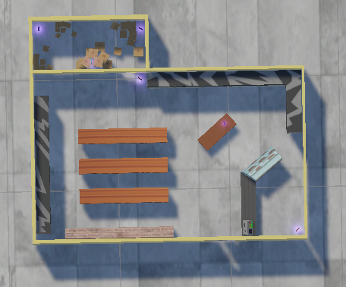
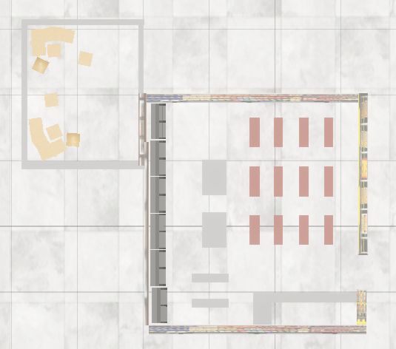
Figure 2: Second iteration Layout
Figure 1: First Iteration Layout

3) Literature Review (Research That Informed Your Design):
Source 1: Ten Principles of good level design (Part 1); Source 2: The Art of Level Design in Video Games; Source 3: Level Design Processes and Challenges: a Cross Section of Game Development
In the first source, they speak about the importance of verticality and making the space interesting to navigate, which comes into play as the players are able to switch between one tall character and two short characters. So within the level, the players are required to use both forms in order to complete the level. So, while our level is quite simple, it does have elements that require players to use the verticality in the level (Taylor, 2013). In the second source, they emphasise a “level’s physical layout” (SAE, 2026), which was taken into consideration, as mentioned previously, with the verticality within the level, the physical layout was important as it had to resemble a petrol station convenience store while still being playable. The third source references how a level is designed as “the space where a player explores the rules and mechanics of a game” (Karlsson, Brusk, & Engstrom, 2023), which is why we made the level in our game a bit more spacious and allowed for some verticality, which allows players to explore the mechanics of both character states, stacked and unstacked.

4) Critical Reflection (Challenges, Changes and Next Steps):
The main thing I found difficult in this role was making the level spacious enough for the players to interact and play around, while also not making it so spacious that it doesn’t matter what they do within the level. So, the design of the level went through a few alterations to get to the final one, which I believe solved the issues I was facing.
I would have investigated the layout of general and convenience stores before starting the level design process, so that I would have had more time to make the level visually appealing and interesting.
Priorities for the next iteration would be: 1. Have a more interesting and unique level design that requires more cooperation between the players and allows for more exploration. 2. Have a better textured environment for a more cohesive visual experience, as well as adding some more fluff to the environment to make it visually interesting. 3. Better time management and spacing so we as a team have more time to make decisions and help one another.
Some risks that I can see coming if we were to continue with this game are trying not to make the levels too similar while still allowing for a similar challenge and feel for the other levels.

References
Karlsson, T., Brusk, J., & Engstrom, H. (2023). Level Design Processes and. Games and Culture, 824.
SAE. (2026, March 09). The Art of Level Design in Video Games. Retrieved from https://www.sae.edu/gbr/insights/the-art-of-level-design-in-video-games/
Taylor, D. (2013, September 29). Ten Principles of Good Level Design (Part 1). Retrieved from Game Developer: https://www.gamedeveloper.com/design/ten-principles-of-good-level-design-part-1-

